COVID 19 – THE RETURN TO WORK

Table of Contents
COVID 19 – THE RETURN TO WORK 1
Background 2
How does Covid 19 affect health and safety legislation? 3
Returning to the workplace 3
Risk assessment and the hierarchy of controls 4
The use of Personal Protective Equipment (PPE) and face coverings 5
Risk assessment for returning to work during the Covid 19 pandemic 6
Premises related 7
People related 10
Moving forward 13

Background

On Sunday 10th May 2020 the Government announced its ‘conditional plan’ to reopen society, including a new Covid Alert System and conditional dates when schools and shops could reopen. The Prime Minister also said that people who cannot work from home should return to the workplace, but avoid public transport wherever possible.

The rules on social distancing and personal hygiene remain unchanged, meaning that businesses must make sure that measures are in place to protect both employees and others.

The latest Government guidance (from 13th May) for England is:

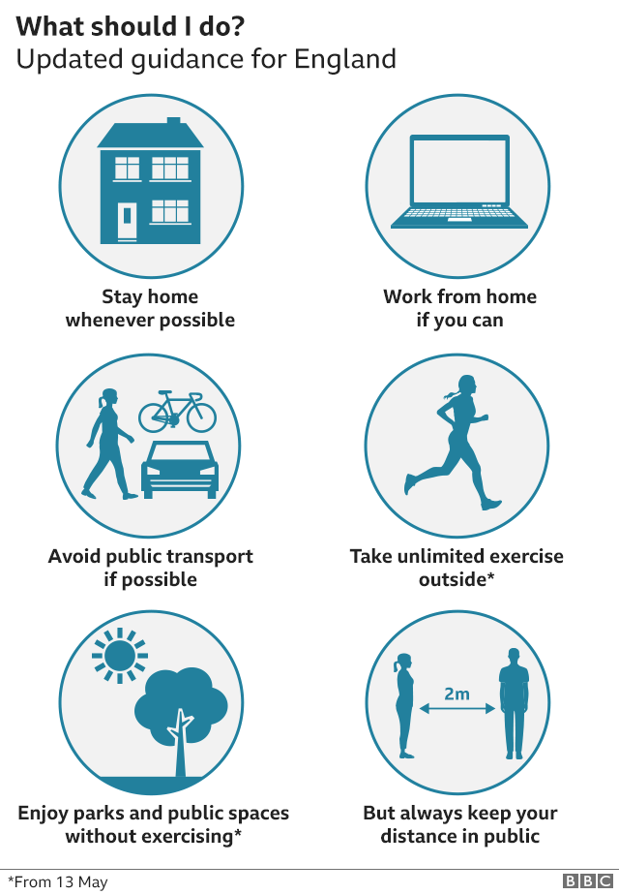

Specific guidance is available for:
- Scotland - https://www.gov.scot/coronavirus-covid-19/
- Wales - https://gov.wales/coronavirus
- Northern Ireland - https://www.nidirect.gov.uk/campaigns/coronavirus-covid-19

The return to work instruction also included an undertaking that businesses would receive guidance on how to become ‘Covid secure’. This guidance is broken down into specific workplaces such as:

- Offices and contact centres
- Factories, plants and warehouses
- Construction and other outdoor work
- Restaurants offering takeaway or delivery
- Labs and research centres
- Shops and branches
- Other people’s homes
- Vehicles

The guidance includes a poster for employers to display, to demonstrate that they have taken the necessary steps outlined:

How does Covid 19 affect health and safety legislation?

The legislation in the UK remains unchanged, meaning that employers still have the same responsibilities for their employees, whether they are working in their usual workplace or elsewhere (e.g. at home or at another location). There is a general acceptance that compliance with all aspects of legislation is difficult during the pandemic (e.g. ensuring compliant workstation set-ups for all employees working from home), however employers still need to take all necessary steps to protect both employers and others.

Returning to the workplace

Following the announcement on 10th May, many employers are now looking at how they can reopen their workplaces. Each workplace is different and the measures required will be different depending on the type of business, size of premises, number of employees etc.

When planning the return to work, a risk assessment will need to be completed so that all hazards can be considered (including those specifically related to Covid 19) and the necessary control measures put into place.

This risk assessment process needs to involve employees, by consulting with employee representatives or union representatives to ensure that everyone has input.

Risk assessment and the hierarchy of controls

Risk assessment is simply a way of looking at what could go wrong, thinking about what is already in place to eliminate or reduce any risks, then identifying any further measures required to reduce the risks further.

Before we start, a few definitions for clarity:

- A hazard is anything with the potential to cause harm (e.g. electricity, trailing leads, working at height, Covid 19).
- Risk is the likelihood of a hazard causing harm, and if it does how serious will it be?
- A control measure is something put in place to eliminate or reduce the risks (e.g. policies/procedures, PAT testing, fire extinguishers, training, maintenance of equipment)
- A hierarchy of controls is a list of actions, in order of preference, that should be taken to eliminate or reduce risks. The first option is always to eliminate wherever possible, and the last option (i.e. when there is no other way to control the risks) is the use of Personal Protective Equipment (PPE). The diagram below illustrates the hierarchy of controls:

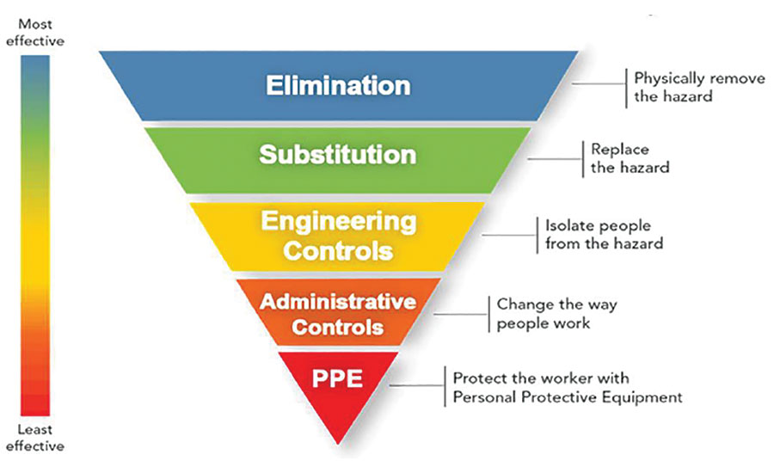

Risk assessment usually follows a five step approach:

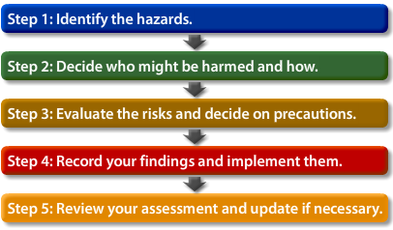

- Identify the hazards
Think about anything that could impact on people (using equipment, electricity, potential for Covid 19 infection etc.)
- Decide who could be harmed and how
Think about other groups that could be affected by your work activities as well as employees (e.g. visitors, contractors, the public)
Is there anyone who is particularly at risk (e.g. pregnant people, people with disabilities, those in the high risk category for Covid 19, young people, the elderly)?
- Evaluate the risks and decide on precautions
Think about what you are already doing and whether there is anything else that can be done to further reduce the risks. For example, would staff benefit from additional training? Do you need to amend any procedures? Do you need to change the workplace layout?
- Record your findings and implement them
Write down what actions you need to take and make sure that they are allocated to someone who can make the relevant adjustments
- Review your assessment and update if necessary
Review the assessment to make sure that it remains valid, both on a regular basis (e.g. every 12 months) and/or when something changes, such as a change in work activities, revised guidance or an incident occurs

The use of Personal Protective Equipment (PPE) and face coverings

Throughout the Covid 19 pandemic, there has been a lot of discussion around the use of PPE, and in particular the use of face masks. Firstly, any PPE that is already in use (e.g. gloves, goggles, boots) should continue to be worn as normal, to ensure that non Covid related hazards are adequately controlled.

The guidance published by the Government on 11th May 2020 states that “workplaces should not encourage the precautionary use of extra PPE to protect against COVID-19 outside clinical settings or when responding to a suspected or confirmed case of COVID-19”.

This means that the precautionary use of surgical face masks should be discouraged, so that supplies of the masks to key workers in clinical settings are not affected. When completing a risk assessment for Covid 19, remember that PPE should only be used when all other controls have been considered (working from home, social distancing, the use of barriers/screens, reduced numbers of people in the workplace, reorganising desks etc.).

The guidance does however go on to mention that face coverings may be useful in situations where people cannot adhere to the 2 metre social distancing rules. A face covering (rather than a face mask) is simply something to cover the mouth and nose (often home made) to stop the individual wearing it from spreading the virus, for example if they already have it but are not yet symptomatic. The wearing of face coverings is optional and they are not the same as PPE; anyone using a face covering needs to ensure that they:

- Wash their hands thoroughly with soap and water for 20 seconds or use hand sanitiser before putting it on and after removing it
- Avoid touching the face or face covering, as this could contaminate them with germs from the hands
- Change the face covering if it becomes damp or if they have touched it
- Continue with regular handwashing
- Change and wash the face covering daily
- If the material is washable, wash in line with manufacturer’s instructions. If it’s not washable, dispose of it carefully in their usual waste
- Practise social distancing wherever possible

Risk assessment for returning to work during the Covid 19 pandemic

When looking at the return to work, as an employer there is a lot that you need to think about. Listed below are a range of items for consideration when completing your risk assessment, including those specific to Covid 19 and other items that need to be considered under ‘business as usual’.

For clarity we have divided these into two sections:
- Premises related
- People related

Premises related

Below are a list of items that need to be considered when reoccupying a business premises. We have listed them in a checklist format for ease of use. These can be used to guide your thinking when completing the risk assessment for your organisation’s circumstances:

Premises related considerations: | Comments:
Have fire alarms and emergency lighting systems been tested in line with regulatory requirements?
Have all water quality tests/monitoring been completed?
Are fire extinguishers present and servicing up to date?
Are security passes still active?
Have you advised your insurance company that the business premises is being reoccupied?
Is PAT testing up to date?
Have statutory tests/inspections been completed under LOLER/PUWER regulations etc. (e.g. lifts, forklift trucks, other equipment)?
Are waste removal contracts in place/reinstated?
Are pest control contracts in place/reinstated?
Are all areas free from waste build-up, all fire exits clear and call points unobstructed?
Are cleaning schedules in place, including additional cleaning for areas of high traffic (e.g. toilets, kitchens, common areas)?
Is soap available for handwashing and hand sanitiser provided?
Is signage in place and clear (e.g. emergency exits, fire extinguishers)?
Is additional signage required (e.g. social distancing guidance, handwashing, one way systems)?
Are arrangements in place for social distancing:
- In common areas (toilets, kitchens, lifts, entrances/exits, break areas)?
- Do you need to consider one way systems, reducing the number of people in lifts, kitchens, toilets etc.?
- Where 2 metre distancing is not possible, do you need to look at screens/barriers?
- Are floor markings required to indicate 2 metre separation?
- Who is going to monitor compliance with social distancing?
- Do you need to consider reducing the number of staff present? (e.g. amended working patterns)
Do cleaners have the correct cleaning materials and PPE?
Workstations:
- Have workstations been assessed to ensure social distancing rules can be observed?
- Does some equipment need to be removed/blocked off to allow adequate space for social distancing?
- Can you change workstations to be side by side rather than face to face?
- Where employees have taken items of equipment home (e.g. chairs, keyboards, screens) do arrangements need to be put in place for their return?
- Are anti-bacterial wipes available for cleaning equipment?
- Do you need to suspend hot desking arrangements to avoid cross contamination?
- Are markings required to indicate 2 metre distancing?
- Where the 2 metre rule cannot be implemented, do you need to provide barriers/screens?
Do you need to provide PPE? NB: in line with the hierarchy of controls, reliance on PPE should be the last consideration
- Is PPE available, obtained from a reputable supplier and compliant with British Standards?
- Are staff aware of how to use and store PPE and how to obtain replacements?
Are arrangements in place for those who cycle/run to work (showers, bike storage, drying rooms etc.)?
Do you need to provide additional car parking facilities, as people are being advised to avoid public transport?
Are specific arrangements in place for Security/Reception areas (signage, social distancing markings, screens, PPE etc.)?
Have emergency arrangements been considered (e.g. evacuation, first aid provision, Fire Wardens)?
NB: In an evacuation situation social distancing may be impossible; in these circumstances the priority is always to evacuate the premises as quickly as possible. Planned evacuation drills should be suspended where social distancing is not possible, however staff need to be made aware of arrangements
Have the arrangements for kitchens/rest facilities been reviewed (e.g. limiting numbers present, cleaning of fridge handles/taps, cleaning of shared crockery/utensils, staff advised to bring own packaged food, possible use of disposable cups/plates/cutlery)?
Are arrangements in place for the reporting of accidents and incidents (including potential cases of Covid 19 believed to have been contracted at work)?
Are arrangements in place for the storage of coats, bags etc. to avoid cross contamination?
Are arrangements in place for the receiving/sending of post parcels etc.?
Do you need to provide extra cleaning materials, limit the number of people handling items, stop the delivery of personal packages etc.?
Do ventilation systems need to be serviced/adjusted prior to reoccupation?
Can windows be opened to provide additional ventilation?
Other (please specify)

People related

Below are a list of items that need to be considered when reoccupying a business premises. We have listed them in a checklist format for ease of use. These can be used to guide your thinking when completing the risk assessment for your organisation’s circumstances:

People related considerations: | Comments:
Which employees are required to return to work? NB: the guidance is still to work from home where possible
- Communication is key; some employees may have caring responsibilities, belong to an ‘at risk’ group or be self-isolating
- Others may be nervous of returning to work before a vaccine is available
Are arrangements in place for those continuing to work from home, including:
- Appropriate workstation set-up?
- Communications with line manager?
- Meetings (e.g. online)?
- Wellbeing considerations? (contact with colleagues, use of EAP, ‘buddy system’ etc.)
Commuting into work:
- Do start/finish times need to be staggered to avoid rush hour commutes?
- Are arrangements in place for those who cycle/run?
- Is adequate car parking available for those who travel by car?
Travel on business:
- Has all non-essential travel been suspended?
- Where travel is unavoidable, have arrangements been put in place (e.g. provision of hand gel, PPE if sharing a vehicle, arrangements at sites to be visited)?
- For essential travel abroad, is the latest FCO guidance being followed?
Are arrangements in place to ensure that staff present are aware of revised arrangements (social distancing, emergency arrangements etc.)?
Is a ‘mini’ induction required?
If PPE is required, have all staff been advised of how it should be used, how to store it and how to get replacements?
Do all staff understand the rules for common areas (restricted numbers in kitchens/rest areas, bringing own packaged food, frequent handwashing, one way systems, lifts, corridors etc.)?
Are staff fully aware of the social distancing guidelines, including at workstations, in common areas, corridors, lifts, toilets, kitchens, entrances etc.?
Have First Aiders been made aware of the latest guidance (i.e. from St John’s Ambulance/NHS)?
Do revised emergency evacuation procedures take account of those who may have difficulty in an evacuation (e.g. those subject to a PEEP)?
Are Fire Wardens aware of revised arrangements and are there sufficient numbers present?
Do working patterns take account of key staff and avoiding the possibility of cross contamination (e.g. having A and B teams who rotate working patterns)?
Are all non-essential visitors/contractors suspended?
Where visitors/contractors are required on site, are arrangements in place to ensure they comply with requirements?
Are meetings arranged to make use of online technology and allow for social distancing?
Are staff aware that the sharing of equipment, pens, cutlery etc. should be avoided?
Are staff encouraged to take sufficient breaks, go outside when possible etc.?
Are arrangements in place for isolating symptomatic individuals?
Are staff aware of the reporting requirements for accidents/incidents and potential Covid 19 cases?
Are arrangements in place to support the wellbeing of employees on an ongoing basis (e.g. regular team meetings, EAP, ‘buddy system’, opportunity to raise concerns)?
Are arrangements in place for the induction of new staff?
Are staff aware of the arrangements for storing coats, bags etc.?
Do you need to put ‘track and trace’ measures in place (e.g. signing up to the Government app, records of working patterns)?
Have you reviewed your Occupational Health provision and any changes in processes (e.g. telephone appointments, urgent referrals)?
Are staff aware of who to report concerns to?
Other (please specify)

Moving forward

The situation regarding Covid 19 is changing rapidly, with advice and guidance being updated on a regular basis. Make sure that you are relying on official sources for the latest information, namely:

- The UK Government (www.gov.uk)
- The Health and Safety Executive (www.hse.gov.uk)
- The National Health Service (www.nhs.uk)

